- 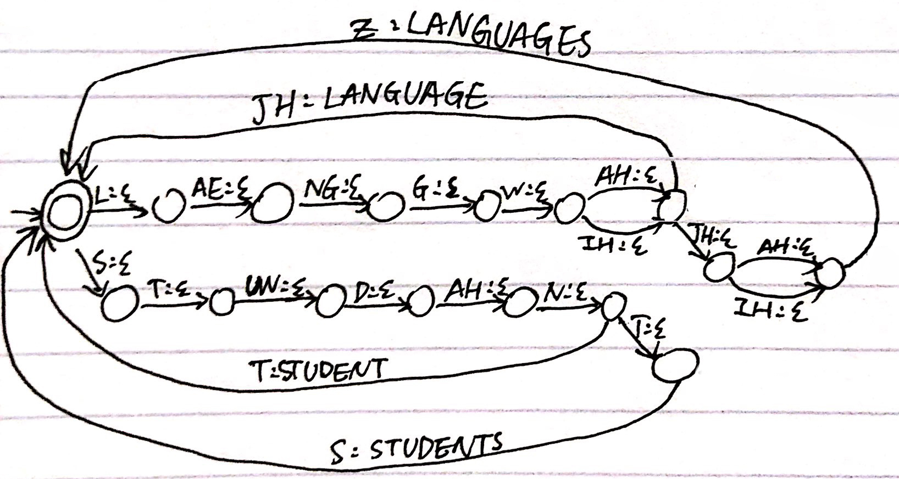

- go(CurrentState, InString, OutString) :-
transition(CurrentState, eps, NextState, eps),
go(NextState, InString, OutString).

- The value of W:
W = [ai, scream] ;
W = [eye, scream] ;
W = [aye, scream] ;
W = [ice, cream] ;
W = [ay, scream] ;
W = [i, scream].

Code for soundslike:
soundslike(X,Y) :-
fst(A,X),
fst(A,Y),
X\=Y.

Description of ?- soundslike([computational, linguistics], A).
A = [com, pew, tay, shun, ul, linguistics] ;
A = [comp, ewe, tay, shun, ul, linguistics] ;
A = [comp, yew, tay, shun, ul, linguistics] ;
A = [comp, u, tay, shun, ul, linguistics] ;
A = [comp, hugh, tay, shun, ul, linguistics] ;
A = [comp, you, tay, shun, ul, linguistics] ;
A = [comp, yu, tay, shun, ul, linguistics] ;
A = [calm, pew, tay, shun, ul, linguistics] ;

Prolog gives 8 lists of strings that is similiar to word ‘computational’, but no string for linguistics. The reason is that there is no combination of words that sounds like linguistics. Since the code for soundslike only check if the output is exactly the same as input, even though ‘linguistics’ can not sound like ‘linguistics’, ‘linguistics’ still appears in evey output string list because ‘computational’ has soundslike lists.

